Arthur Silverstein, Hanqing Wang, Margaret Schmit

CS 184 Final Project Manual: Face Scanner App

**Login**

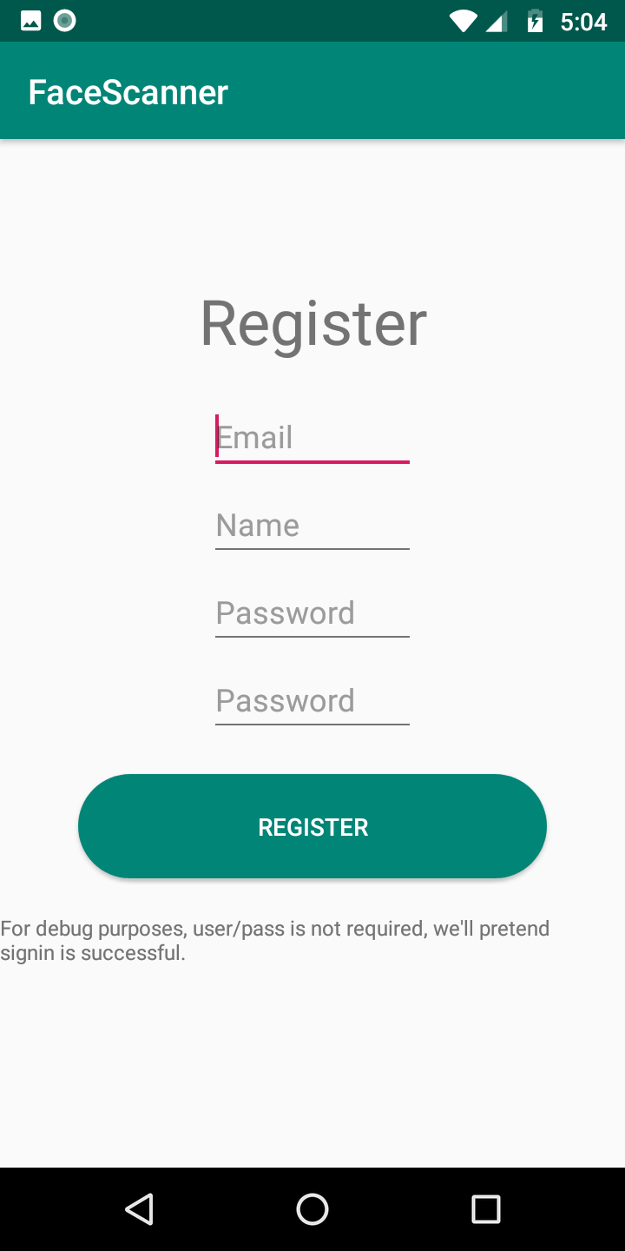 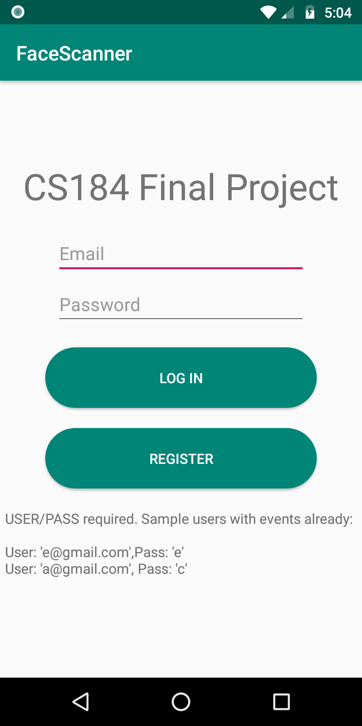

This is the first screen you see when you open the application. It asks the user to sign in to their club using their email and their unique club password. Each club has one sign in that they share.

If your club does not already have a unique sign in, you can create one by clicking the “Register” button. This will ask for an email, your club name, and a password. After you have registered your club, you can sign into your club. The side note for the “Register” screenshot has since been changed in the latest version, which does require a username/password.

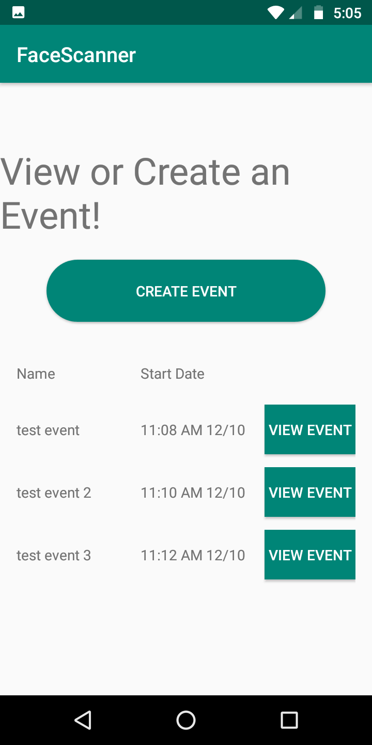

After you have an organization, log in and create an event. If you’ve already created an event, tap it to view.

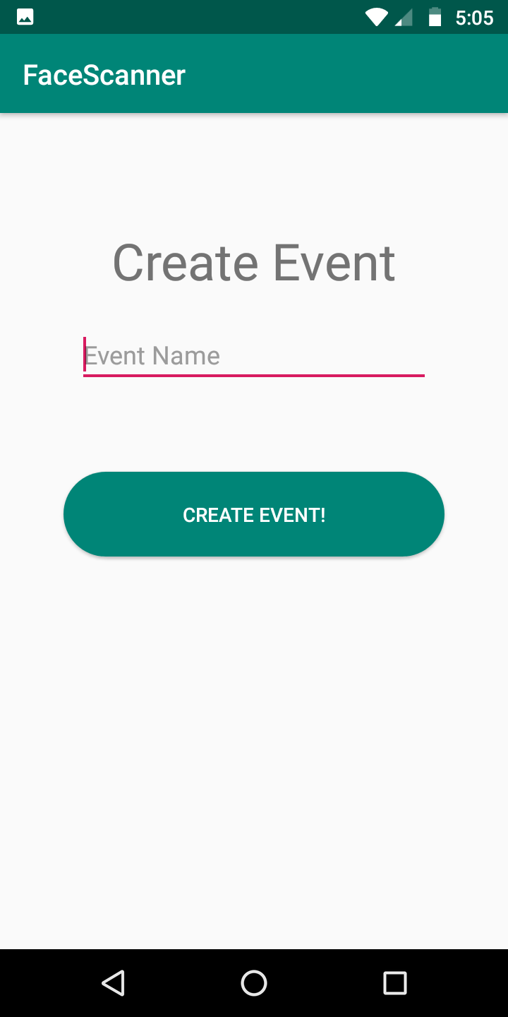

This is the screen that allows the user to create a new event. All you need for an event is a name, and the start date is automatically set to the day you create the event.

After you create an event, you are returned to the view events page, where you can click on the view event button.

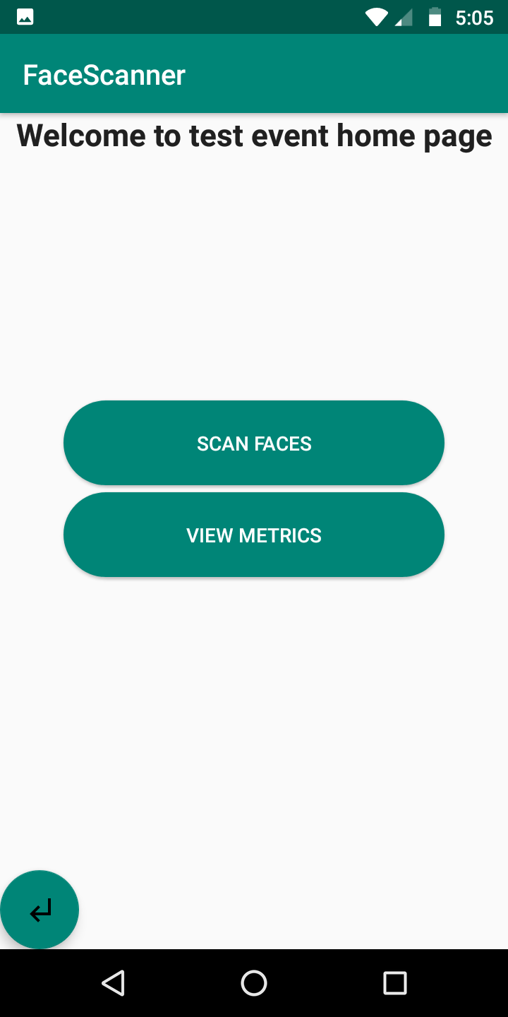

This is the Event home page.

From here, you can either check the event metrics or start scanning people. Tap the Scan button to scan.

After taking a picture of someone, you’ll get a prompt to either confirm their name or add them as a member (depending on whether or not they were registered with your organization already).

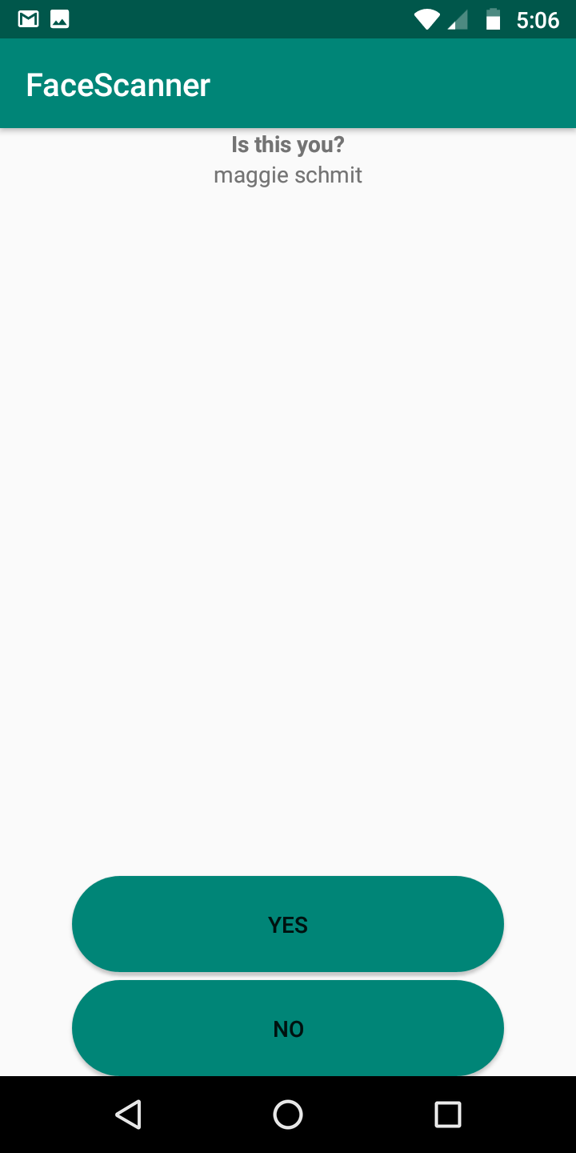

If the person whose face you scanned is already a member of the club, you will get a screen confirming who the member is. This will display the first and last name of the face that the algorithm recognized.

If this is the correct member, then you can click the ‘Yes’ button.

If this is not the correct member, then you can click the ‘No’ button.

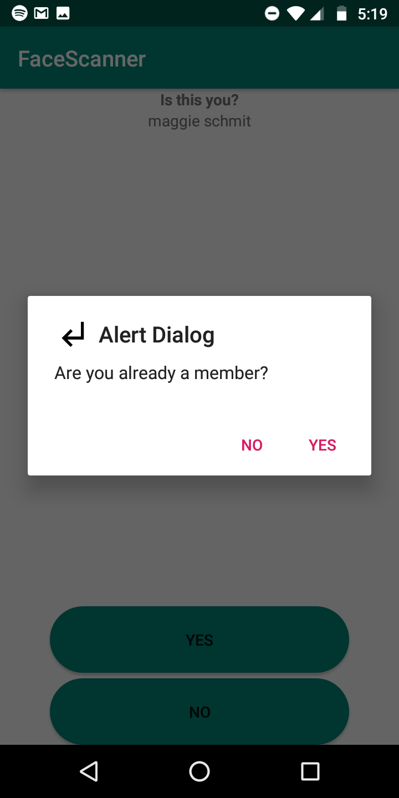

When you select ‘No’, you get this dialog. If the person is a member of the club, you can select ‘Yes’. This will return you to the event home page, from which you can re-scan the member’s face.

If you select ‘Yes’, you will get the ‘Create New Member’ dialog.

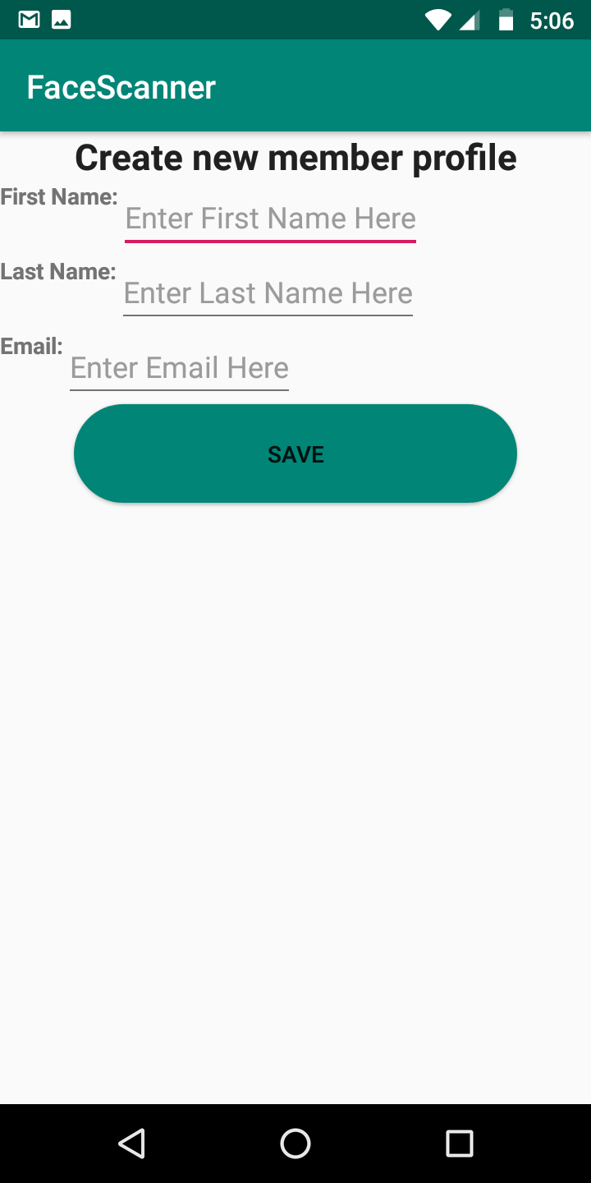

To create a member profile, enter first name, last name, and an email and press the save button. Your member profile will be saved by the server and it will be used to recognize you in the future.

This screen will also appear if you scan a face and that face does not match with any members in your club.

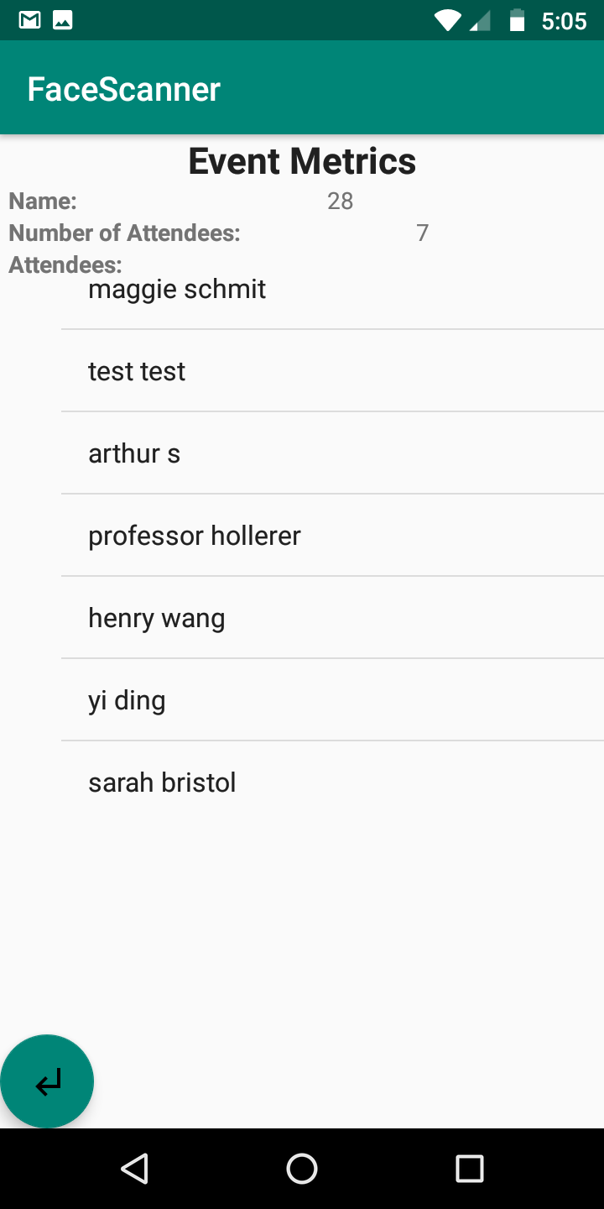

On the Event Metrics page, you can view every member that has already checked in to the event. This page shows the name of the event and how many people have attended. You can return to the event main menu from the button on the bottom left corner.